**IICT**

**SEMESTER PROJECT**

**GROUP:**

**Mavra Mehak 22i-0798**

**Maryum Tanvir 22i-0751**

**Maaz Khan 22i-2125**

**Salman Khan 22i-1285**

**INTRODUCTION:**

“Mcubix” is a website which serves the purpose of an online grocery shop. The main purpose of this page is to provide grocery items of best quality to the customers from the comfort of their homes and have them delivered at their doorstep.

**LOGIN PAGE:**

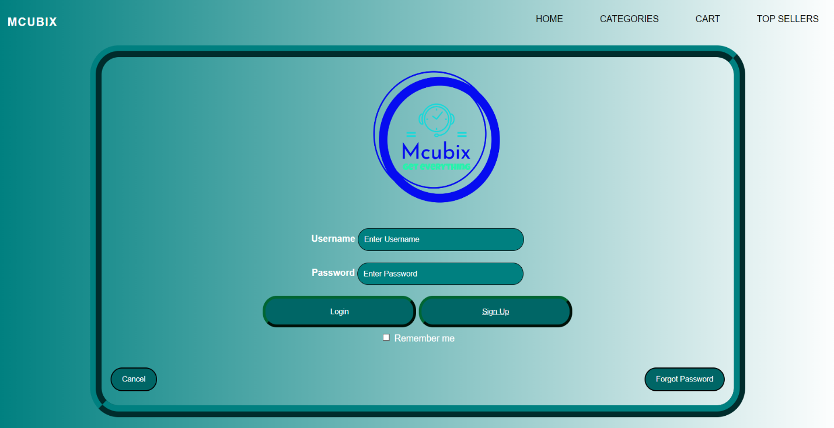

* To start shopping, the user must first login by clicking on the login tab which opens up the login page. On this page, the user can see a username and password bar where they must enter their details.
* If it is a new user, they can click on the sign-up button provide below or they can click on the sign-up tab.
* There is also a “forgot password” button available for the user just in case.

**SIGN UP PAGE:**

The sign-up page is for new users who do not yet have an account. It provides the user with tabs to enter in their details such as their email, password and phone number. When all the details are provided by the user, the website creates an account for them, and they can then go to the login page to login and start shopping in the browse page

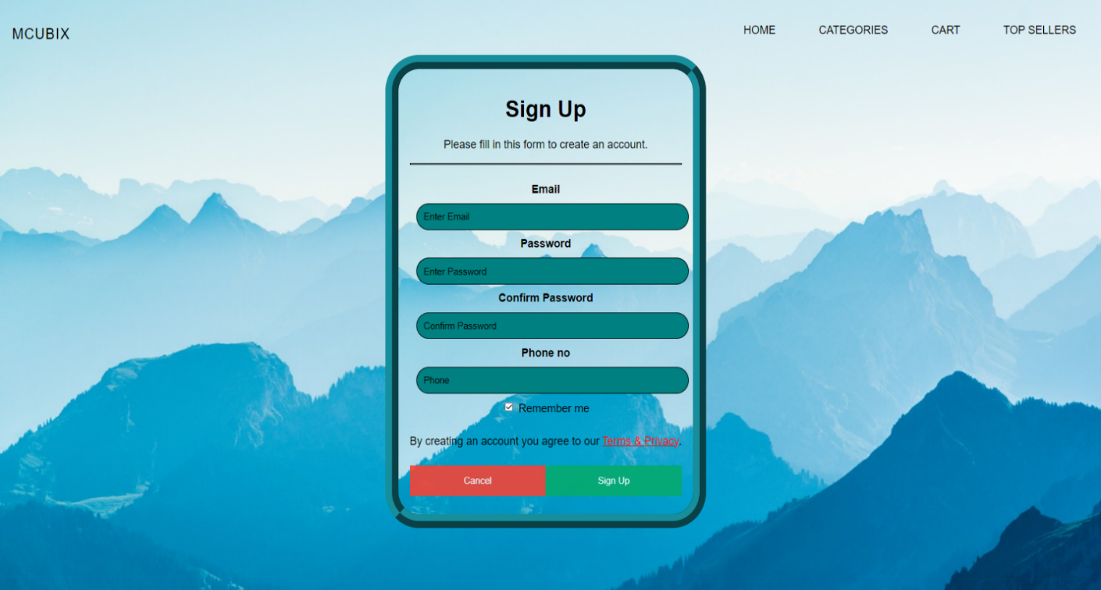

**MAIN PAGE:**

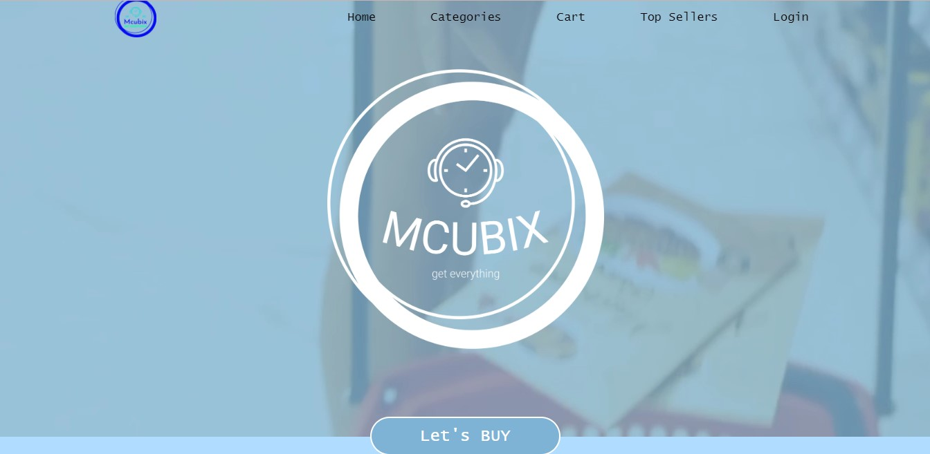The main page greets the user to the website and provides them with the plethora of sub-menus on the top ribbon. It includes login, sign-up, home, top seller, categories, cart and payment.

**TOP SELLERS:**

The top sellers page shows the most popular items of the grocery store in a slide show. This page is updated according to our best-selling items which are customer favorites.

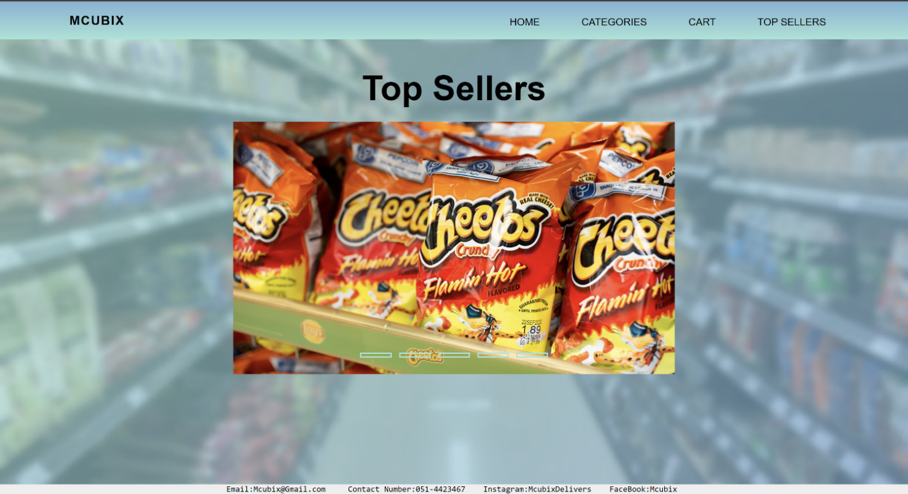

**CATEGORIES:**

The categories page allows the user to go through various grocery items according to their choice.

Initially, the customer is greeted with a banner/home page:

Next, a category section appears which includes different categories like:

vegetables, dairy products, fruits, processed Items, beverages, and meat.

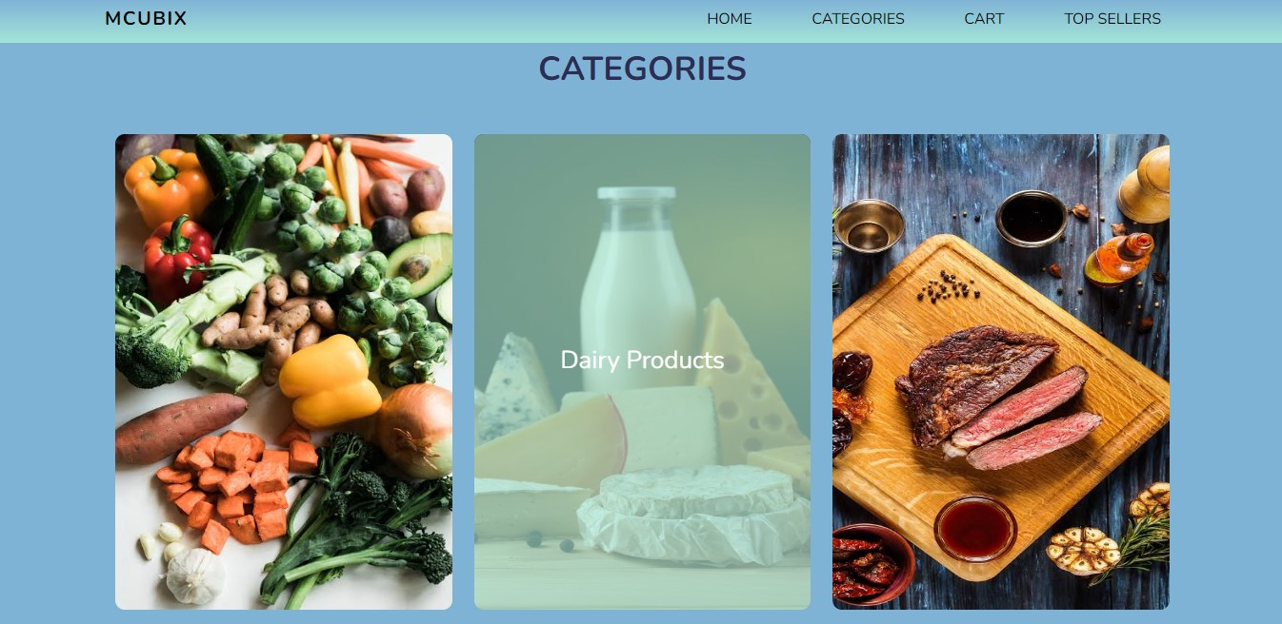

It further gives a list of all the items regarding each category along with their prices. An option to add that item to the cart is also provided along with the designated box to specify the total quantity of items to be purchased or added.

**PAYMENT PAGE:**

The payment page provides the user with spaces to enter all their details regarding the transaction. These include their name, address, zip code and credit card number. When the user enters all the required information, they can proceed to the cart page and after the transaction process completes, their groceries will be delivered at their doorstep.

